**SpringBoot-SpringDataJPA-MYSQL-SOAPUI Sample Application**

**Prerequisites**

We must have installed the following

* JDK 1.7 or later
* Maven 3 or later

**Project Structure**

├── src

│   └── main

│   ├── java

│   │   └── com

│   │   └── springboot

│   │   └── springdatajpa

│   │   ├──Controller

│   │   │ └──BookingController.java

│ │ ├──models

│ │ │ ├── Booking.java

│   │ │ └── BookingRepository.java

│  │  SpringBootJpaSpringDataApplication.java

│   └── resources

│     ├── application.properties

│ └── hibernate.properties

│

└── pom.xml

**Project dependencies**

|  |
| --- |
| **Pom.xml** |
| <?xml version="1.0" encoding="UTF-8"?>  <project xmlns="http://maven.apache.org/POM/4.0.0" xmlns:xsi="http://www.w3.org/2001/XMLSchema-instance"  xsi:schemaLocation="http://maven.apache.org/POM/4.0.0 http://maven.apache.org/xsd/maven-4.0.0.xsd">  <modelVersion>4.0.0</modelVersion>  <groupId>com.springdatajpa.sdjpa</groupId>  <artifactId>springdb</artifactId>  <version>0.0.1-SNAPSHOT</version>  <packaging>jar</packaging>  <name>SpringBootJPASpringData</name>  <description>SpringBootJPASpringData project for Spring Boot with Spring Data JPA implementation</description>  <parent>  <groupId>org.springframework.boot</groupId>  <artifactId>spring-boot-starter-parent</artifactId>  <version>1.4.0.RELEASE</version>  <relativePath/> <!-- lookup parent from repository -->  </parent>  <properties>  <project.build.sourceEncoding>UTF-8</project.build.sourceEncoding>  <project.reporting.outputEncoding>UTF-8</project.reporting.outputEncoding>  <java.version>1.8</java.version>  </properties>  <dependencies>  <dependency>  <groupId>org.springframework.boot</groupId>  <artifactId>spring-boot-starter-data-jpa</artifactId>  </dependency>  <dependency>  <groupId>org.springframework.boot</groupId>  <artifactId>spring-boot-starter-web</artifactId>  </dependency>  <dependency>  <groupId>mysql</groupId>  <artifactId>mysql-connector-java</artifactId>  <scope>runtime</scope>  </dependency>    </dependencies>  <build>  <plugins>  <plugin>  <groupId>org.springframework.boot</groupId>  <artifactId>spring-boot-maven-plugin</artifactId>  </plugin>  </plugins>  </build>  </project> |

**Application Configuration**

|  |
| --- |
| **SpringBootJpaSpringDataApplication.java** |
| **Path 🡪 src/main/java/com/test/sdjpa/ SpringBootJpaSpringDataApplication.java** |
| package com.test.sdjpa;  import org.springframework.boot.SpringApplication;  import org.springframework.boot.autoconfigure.SpringBootApplication;  @SpringBootApplication  public class SpringBootJpaSpringDataApplication {  public static void main(String[] args) {  SpringApplication.run(SpringBootJpaSpringDataApplication.class, args);  }  } |

**Controller File**

|  |
| --- |
| **BookingController.java** |
| **Path 🡪 src/main/java/com/test/sdjpa/** **BookingController.java** |
| package com.springboot.springdatajpa.controller;  import java.util.ArrayList;  import java.util.Date;  import java.util.HashMap;  import java.util.List;  import java.util.Map;  import javax.validation.Valid;  import org.springframework.beans.factory.annotation.Autowired;  import org.springframework.web.bind.annotation.RequestBody;  import org.springframework.web.bind.annotation.RequestMapping;  import org.springframework.web.bind.annotation.RestController;  import com.springboot.springdatajpa.models.Booking;  import com.springboot.springdatajpa.models.BookingRepository;  /**  * @author Dinesh.Rajput  *  */  @RestController  @RequestMapping("/booking")  public class BookingController {    @Autowired  BookingRepository bookingRepository;  /**  * GET /create --> Create a new booking and save it in the database.  */      @RequestMapping("/create")    public Booking create(@Valid @RequestBody Booking booking) {  booking.setTravelDate(new Date());  booking = bookingRepository.save(booking);  return booking;  }    /**  * GET /read --> Read a booking by booking id from the database.  */      @RequestMapping("/read")  public Booking read(@Valid @RequestBody Booking booking) {      System.out.println("bookingId"+booking.getBookingId());  Booking book = bookingRepository.findOne(booking.getBookingId());  return book;  }    @RequestMapping("/readAll")  public List<Booking> readAll() {      Iterable<Booking> book = bookingRepository.findAll();  List<Booking> list = new ArrayList<Booking>();  if(book != null) {  for(Booking e: book) {  list.add(e);  }  }  return list;  }  /**  * GET /update --> Update a booking record and save it in the database.  */      @RequestMapping("/update")  public Booking update(@Valid @RequestBody Booking book) {  Booking booking = bookingRepository.findOne(book.getBookingId());  booking.setPsngrName(book.getPsngrName());  booking.setDeparture(book.getDeparture());  booking.setDestination(book.getDestination());  booking.setTravelDate(new Date());  booking = bookingRepository.save(booking);  return booking;  }    /**  * GET /delete --> Delete a booking from the database.  */    @RequestMapping("/delete")  public Map<String, Object> delete(@Valid @RequestBody Booking book) {  Map<String, Object> dataMap = new HashMap<String, Object>();    bookingRepository.delete(book.getBookingId());  dataMap.put("bookingId", book);  dataMap.put("Status", "Successfully Deleted");  return dataMap;  }  } |

**Model File**

|  |
| --- |
| **Booking.java** |
| **Path 🡪 src/main/java/com/test/sdjpa/** **Booking.java** |
| package com.test.sdjpa.models;  import java.io.Serializable;  import java.util.Date;  import javax.persistence.Column;  import javax.persistence.Entity;  import javax.persistence.GeneratedValue;  import javax.persistence.GenerationType;  import javax.persistence.Id;  import javax.persistence.Table;  @Entity  @Table(name = "BOOKING")  public class Booking implements Serializable{  /**  *  */  private static final long serialVersionUID = 1L;  @Id  @GeneratedValue(strategy = GenerationType.AUTO)  Long bookingId;  @Column  String psngrName;  @Column  String departure;  @Column  String destination;  @Column  Date travelDate;  public Long getBookingId() {  return bookingId;  }  public void setBookingId(Long bookingId) {  this.bookingId = bookingId;  }  public String getPsngrName() {  return psngrName;  }  public void setPsngrName(String psngrName) {  this.psngrName = psngrName;  }  public String getDeparture() {  return departure;  }  public void setDeparture(String departure) {  this.departure = departure;  }  public String getDestination() {  return destination;  }  public void setDestination(String destination) {  this.destination = destination;  }  public Date getTravelDate() {  return travelDate;  }  public void setTravelDate(Date travelDate) {  this.travelDate = travelDate;  }    } |

|  |
| --- |
| **BookingRepository.java** |
| **Path 🡪 src/main/java/com/test/sdjpa/** **BookingRepository.java** |
| package com.test.sdjpa.models;  import org.springframework.data.repository.CrudRepository;  import org.springframework.transaction.annotation.Transactional;  @Transactional  public interface BookingRepository extends CrudRepository<Booking, Long> {    /**  * This method will find an Boooking instance in the database by its departure.  * Note that this method is not implemented and its working code will be  * automatically generated from its signature by Spring Data JPA.  */  public Booking findByDeparture(String departure);  } |

**Application.properties**

|  |
| --- |
| **application.properties** |
| **Path 🡪 src/main/resources/application.properties** |
| # DataSource settings: set here your own configurations for the database  # connection. In this example we have "dojsb" as database name and  # "root" as username and password.  spring.datasource.url = jdbc:mysql://localhost:3306/test  spring.datasource.username = root  spring.datasource.password = root  # Keep the connection alive if idle for a long time (needed in production)  spring.datasource.testWhileIdle = true  spring.datasource.validationQuery = SELECT 1  # Show or not log for each sql query  spring.jpa.show-sql = true  # Hibernate ddl auto (create, create-drop, update)  spring.jpa.hibernate.ddl-auto = create  # Naming strategy  spring.jpa.hibernate.naming-strategy = org.hibernate.cfg.ImprovedNamingStrategy  # Use spring.jpa.properties.* for Hibernate native properties (the prefix is  # stripped before adding them to the entity manager)  # The SQL dialect makes Hibernate generate better SQL for the chosen database  spring.jpa.properties.hibernate.dialect = org.hibernate.dialect.MySQL5Dialect  server.port = 8082 |

**Steps to Test the Application**

D:\Karthik-ws\code\SpringBoot-SpringDataJPA-Mysql >mvn spring-boot:run

Once the server has been started. Enter the below url in the SOAPUI and select POST method.

**Insert**

[http://localhost:8082/booking/create](http://localhost:8181/booking/create)

|  |
| --- |
| JSON Input |
| {  "psngrName": "monisha",  "departure": "chennai",  "destination": "salem",  "travelDate": 1485779940000  } |

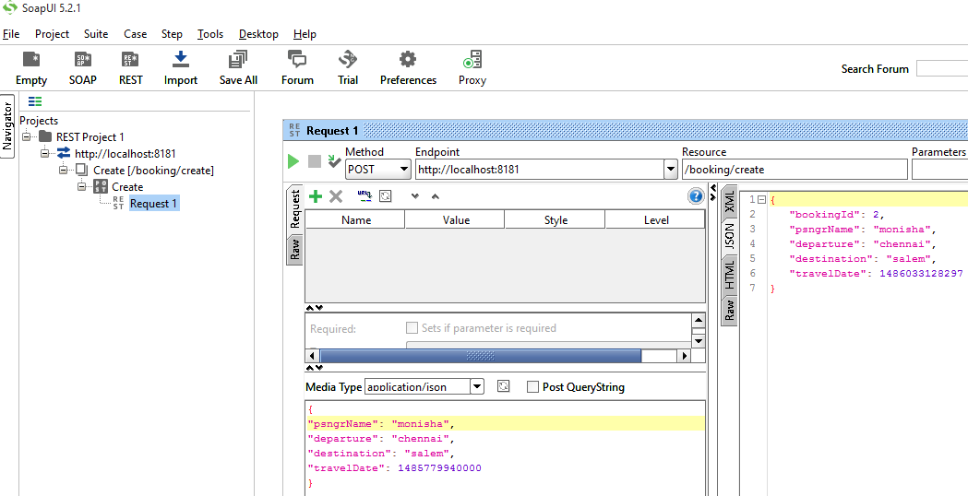

**Update**

[http://localhost:8082/booking/update](http://localhost:8181/booking/update)

|  |
| --- |
| JSON Input |
| {  "bookingId": 5,  "psngrName": "karthik",  "departure": "chennai",  "destination": "erode",  "travelDate": 1486115985775  } |

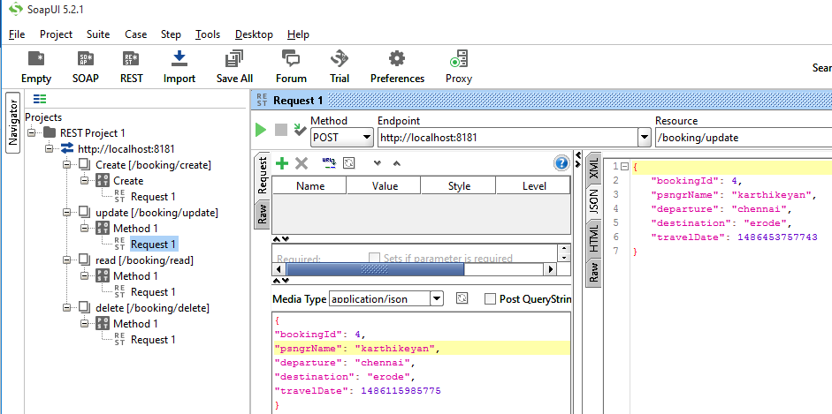

**View**

http://localhost:8082/booking/read

|  |
| --- |
| JSON Input |
| {  "bookingId":4  } |

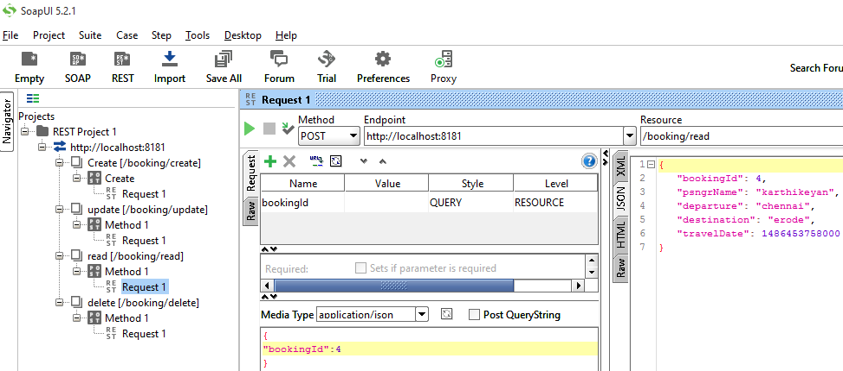

**Delete**

[http://localhost:8082/booking/delete](http://localhost:8181/booking/delete)

|  |
| --- |
| JSON Input |
| {  "bookingId":3  } |

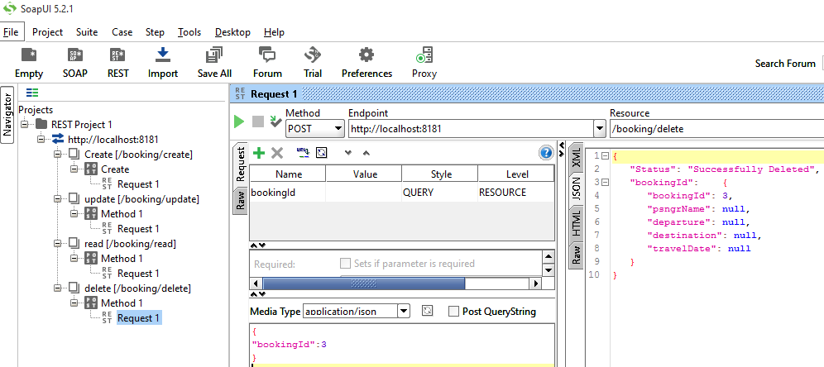

**View All**

[http://localhost:8082/booking/readAll](http://localhost:8181/booking/readAll)

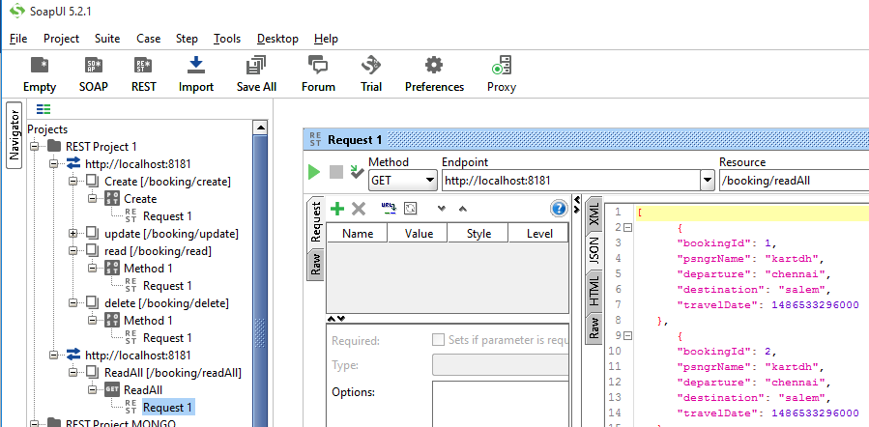

**Test in mysql Client**

